FINAL REPORT
Compact I–V Modeling of Double-Gated MoS₂ FETs Including Short-Channel Effects
Submitted by:
Spurthi H (230932002)
Prakhar Singh (230907450)
Mayank Kumar Singh (230907350)

Introduction
With the rapid scaling of semiconductor devices, conventional silicon MOSFETs face significant challenges such as short-channel effects and increased leakage current, which degrade device performance. Two-dimensional materials like MoS₂ have emerged as promising alternatives due to their excellent electrostatic control, ultra-thin structure, and improved scalability. This project focuses on developing a compact current–voltage (I–V) model for double-gated MoS₂ FETs to accurately capture device behavior, including short-channel effects, for nanoscale applications.

Abstract
This project presents a detailed study and development of a compact analytical current–voltage (I–V) model for double-gated MoS₂ field-effect transistors (FETs). The model is derived using a unified charge control approach, where the charge density is expressed analytically using the Lambert W function. This formulation ensures a smooth and continuous transition across all regions of operation, including subthreshold and strong inversion.
To enhance model accuracy, important short-channel effects such as Drain-Induced Barrier Lowering (DIBL), mobility degradation, velocity saturation, and channel length modulation (CLM) are incorporated. MATLAB simulations are carried out for channel lengths of 500 nm, 200 nm, and 60 nm. The results demonstrate realistic transistor characteristics and validate the correctness of the developed model for different channel lengths.

Objectives
The objectives of this project are:
• To study the structure and working of double-gated MoS₂ FETs.
• To develop a compact analytical I–V model using charge control principles.
• To incorporate short-channel effects such as DIBL, mobility degradation, velocity saturation, and CLM.
• To simulate transfer and output characteristics using MATLAB.
• To analyze the impact of scaling on device performance.
• To validate the model with expected transistor behavior.

Methodology
The modeling approach is based on a physics-driven charge control model. The electrostatics of the double-gated MoS₂ FET are first analyzed using oxide capacitance and quantum capacitance concepts.
The nonlinear charge equation is solved using the Lambert W function, which provides a closed-form analytical solution. This ensures continuity across all operating regions and avoids the need for piecewise modeling.
The drain current equation is derived using charge densities at the source and drain ends of the channel. To improve realism, short-channel effects are incorporated into the model. MATLAB is then used to simulate the device characteristics and analyze the results for different channel lengths.

Procedure
The procedure followed in this project is:
1. Study the device physics of double-gated MoS₂ FET.
2. Derive electrostatic equations based on capacitance models.
3. Develop the unified charge control model.
4. Apply the Lambert W function to obtain analytical solutions.
5. Derive the drain current equation.
6. Incorporate short-channel effects into the model.
7. Implement the model in MATLAB.
8. Generate transfer, output, and transconductance plots.
9. Analyze and interpret the results.

Simulation Implementation
The developed compact I–V model of the double-gated MoS₂ FET was implemented using a simulation framework to evaluate device behaviour under different bias conditions. The implementation includes the analytical charge model based on the Lambert W function along with the incorporation of key short-channel effects such as drain-induced barrier lowering (DIBL), mobility degradation, velocity saturation, and channel length modulation.
The simulation involves sweeping the gate voltage (Vgs) and drain voltage (Vds) for different channel lengths (500 nm, 200 nm, and 60 nm). For each bias condition, the drain current (Ids) is computed using the derived equations.
A numerical method is used to evaluate the Lambert W function efficiently, ensuring accurate computation of charge density. The simulated data is then used to generate transfer characteristics, output characteristics, and transconductance plots.
The implementation validates the correctness of the developed model and demonstrates its capability to capture realistic transistor behaviour.

Results

1. Transfer Characteristics (Id–Vgs)
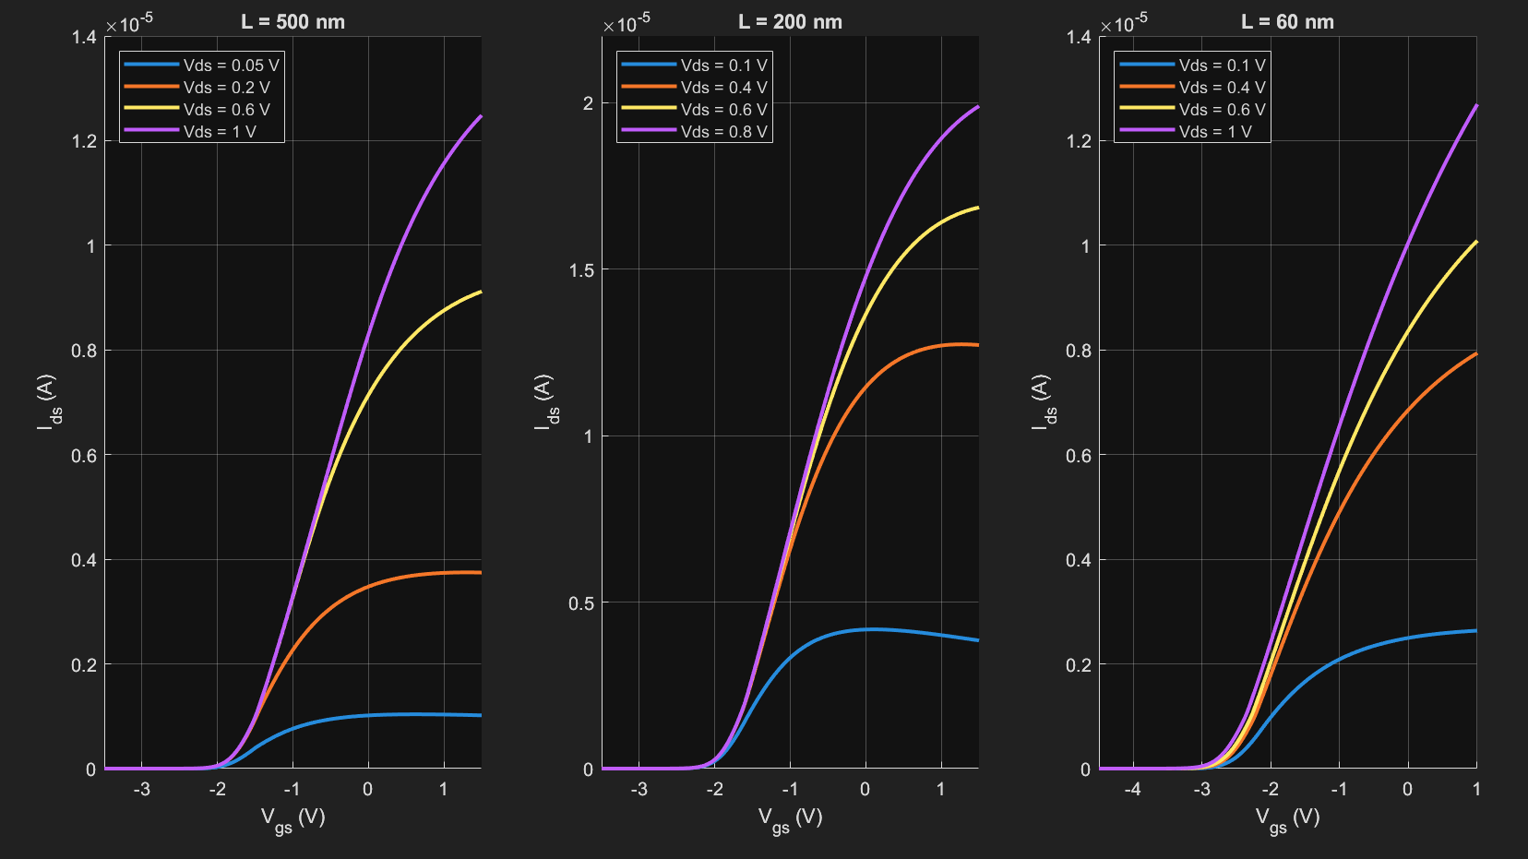
Figure 1: Linear Transfer Characteristics (Id–Vgs)
The linear transfer characteristics plot shows the variation of drain current (Id) with gate voltage (Vgs) for different drain voltages. As the gate voltage increases, the channel becomes more conductive, resulting in an increase in drain current.
A smooth transition from the subthreshold region to the strong inversion region is observed, indicating proper device operation. At higher drain voltages, the current increases further due to enhanced carrier transport. This behavior confirms that the model accurately captures the transistor switching characteristics.

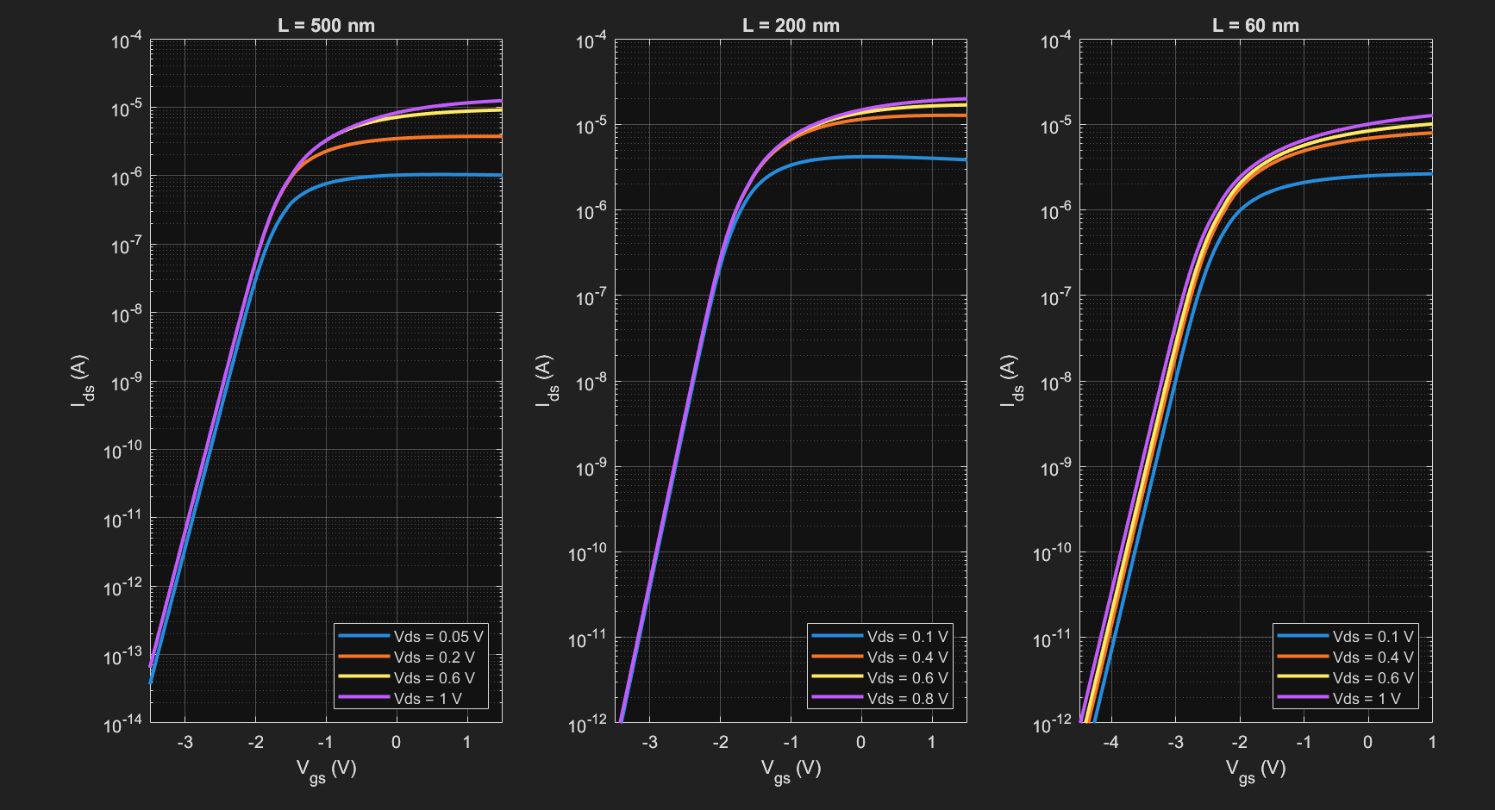
Figure 2: Log Scale Transfer Characteristics
The logarithmic transfer characteristics highlight the subthreshold region of operation. In this region, the drain current increases exponentially with gate voltage, which is a key feature of FET behavior.
The plots show that as the channel length decreases, the leakage current increases significantly. This is due to the presence of short-channel effects such as DIBL. The slope of the curve also indicates the subthreshold swing of the device, which is an important parameter for low-power applications.

2. Output Characteristics (Id–Vds)
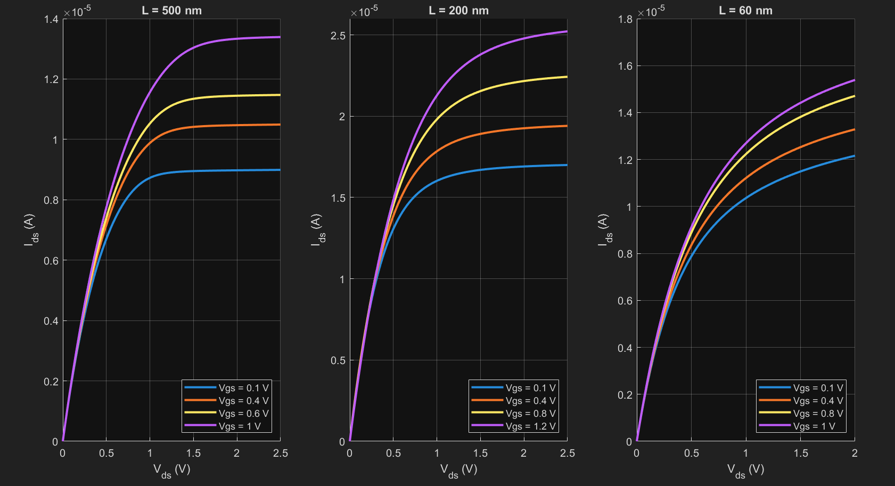
Figure 3: Output Characteristics (Id–Vds)
The output characteristics show the variation of drain current (Id) with drain voltage (Vds) for different gate voltages. At low Vds, the device operates in the linear region, where current increases linearly with voltage.
As Vds increases, the device enters the saturation region, where the current becomes relatively constant. However, a slight increase in current is observed even in saturation, which indicates the presence of channel length modulation. This behavior is more pronounced in shorter channel devices.

3. Transconductance (gm vs Vgs)
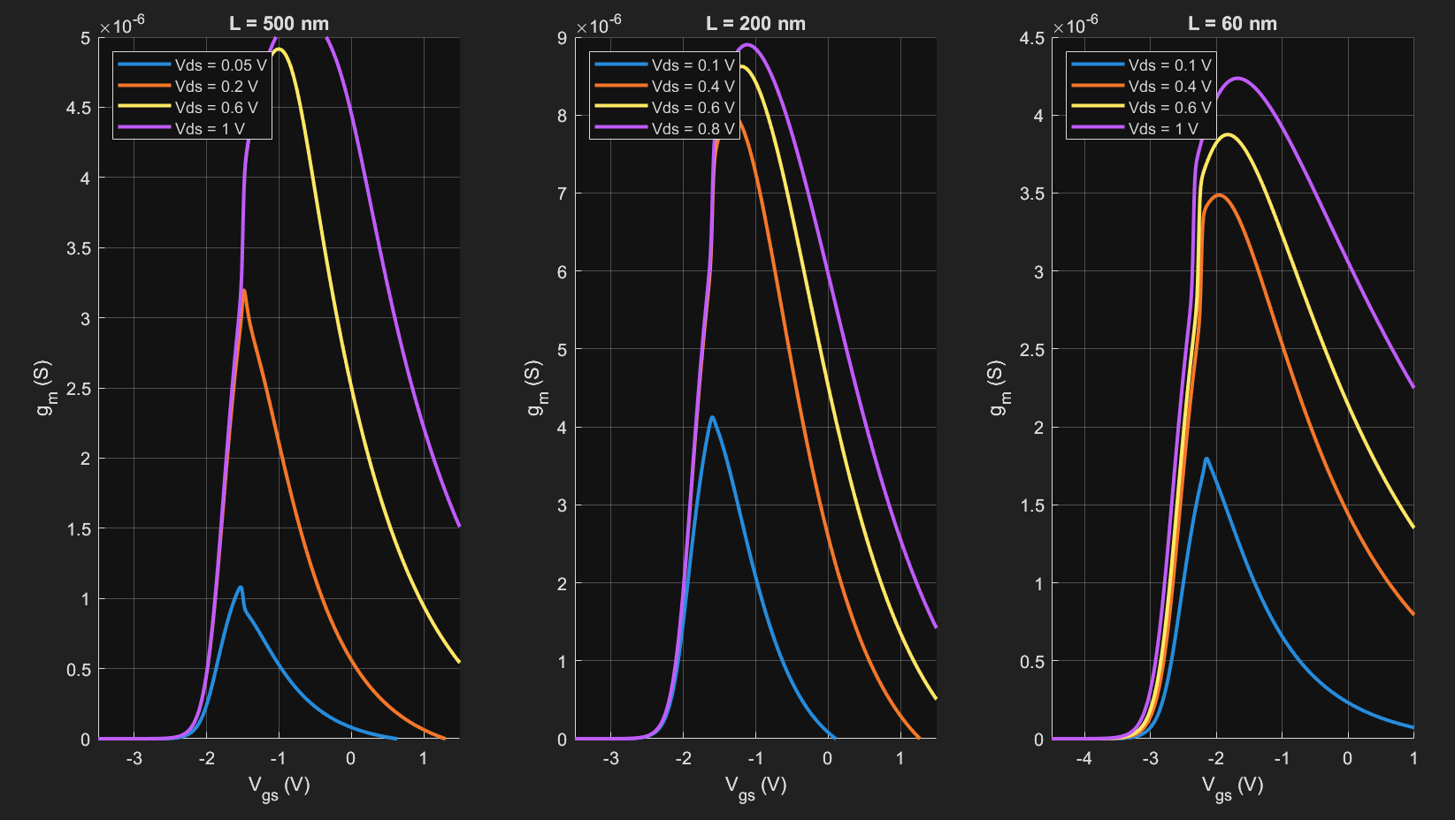
Figure 4: Transconductance (gm vs Vgs)
The transconductance plot shows the variation of gm with gate voltage. Initially, gm increases as the gate voltage increases, indicating improved channel conductivity.
A peak value of gm is observed, after which it starts decreasing. This reduction is due to mobility degradation at higher electric fields. The transconductance behavior provides insight into the gain and performance of the device.

Code
BEGIN

1. Initialize Environment
- Clear variables, command window, and close figures

2. Define Physical Constants
- q, kB, T
- Thermal voltage Vth = (kB * T) / q

3. Define Oxide Capacitances
- Compute C_Al2O3
- Compute C_HfO2
- Compute total capacitance Ct

4. Define Model Constants
- Cdq, V_norm, V_min, V_error

5. Define Device Parameters for 3 Devices
FOR each device i = 1 to 3
- Assign L, W, mobility (mu)
- Assign threshold voltage (Vg0)
- Assign alpha, velocity saturation (vsat)
- Assign nu, m, lambda, DIBL
END FOR

6. Define Voltage Sweeps
- Vds_sweep: range from 0 to 2.5 V
- Define Vds_steps for each device
- Define Vgs_steps for each device

7. Create Figures
- Linear Ids vs Vgs
- Log Ids vs Vgs
- Transconductance (gm vs Vgs)
- Output characteristics (Ids vs Vds)

8. Loop Over Each Device
FOR each device i = 1 to 3

- Select appropriate Vgs sweep range

--- Transfer Characteristics ---
FOR each Vds value in Vds_steps[i]

FOR each Vgs value
- Compute Ids using calc_Ids()
END FOR

- Compute transconductance gm = dIds/dVgs

- Plot:
• Linear Ids vs Vgs
• Log Ids vs Vgs
• gm vs Vgs

END FOR

--- Output Characteristics ---
FOR each Vgs value in Vgs_steps[i]

FOR each Vds value
- Compute Ids using calc_Ids()
END FOR

- Plot Ids vs Vds

END FOR

END FOR

9. Function: calc_Ids(Vg, Vds, device, constants)
- Compute overdrive voltage Vov
- Compute effective mobility mueff
- Compute saturation voltage Vds_sat
- Compute effective Vds (Vds_eff)

- Compute source charge Qs
- Compute drain charge Qd

- Compute charge-based current term

- Compute velocity saturation factor
- Compute channel length modulation factor

- Compute Ids
- Ensure Ids ≥ minimum value

RETURN Ids

10. Supporting Functions
- calc_Q(): Computes charge using Lambert W function
- calc_Vov(): Computes overdrive voltage
- calc_mueff(): Computes effective mobility
- calc_Vds_sat(): Computes saturation voltage
- calc_Vds_eff(): Computes effective drain voltage

END

Simulation Output
=================================================
SIMULATION 1: TRANSFER CHARACTERISTICS (Ids vs Vgs)
=================================================

Table 1: L = 500 nm
Vgs (V) | Ids @ Vds=0.1V | Ids @ Vds=0.5V | Ids @ Vds=1.0V
-3.0 | 5.46 × 10⁻¹² | 6.50 × 10⁻¹² | 6.51 × 10⁻¹²
-2.0 | 5.48 × 10⁻⁸ | 6.52 × 10⁻⁸ | 6.53 × 10⁻⁸
-1.0 | 1.87 × 10⁻⁴ | 2.57 × 10⁻⁴ | 2.52 × 10⁻⁴
0.0 | 1.07 × 10⁻³ | 3.26 × 10⁻³ | 3.60 × 10⁻³
1.0 | 1.43 × 10⁻³ | 5.38 × 10⁻³ | 7.65 × 10⁻³

Table 2: L = 200 nm
Vgs (V) | Ids @ Vds=0.1V | Ids @ Vds=0.5V | Ids @ Vds=1.0V
-3.0 | 3.90 × 10⁻¹¹ | 4.52 × 10⁻¹¹ | 4.53 × 10⁻¹¹
-2.0 | 3.15 × 10⁻⁷ | 3.66 × 10⁻⁷ | 3.66 × 10⁻⁷
-1.0 | 6.00 × 10⁻⁴ | 8.58 × 10⁻⁴ | 8.27 × 10⁻⁴
0.0 | 2.37 × 10⁻³ | 6.66 × 10⁻³ | 7.47 × 10⁻³
1.0 | 2.89 × 10⁻³ | 1.03 × 10⁻² | 1.39 × 10⁻²

Table 3: L = 60 nm
Vgs (V) | Ids @ Vds=0.1V | Ids @ Vds=0.5V | Ids @ Vds=1.0V
-4.0 | 4.59 × 10⁻¹² | 1.07 × 10⁻¹¹ | 2.21 × 10⁻¹¹
-2.0 | 8.39 × 10⁻⁶ | 1.89 × 10⁻⁵ | 3.58 × 10⁻⁵
-1.0 | 7.32 × 10⁻⁴ | 1.79 × 10⁻³ | 2.24 × 10⁻³
0.0 | 1.49 × 10⁻³ | 4.50 × 10⁻³ | 5.84 × 10⁻³
1.0 | 1.88 × 10⁻³ | 6.44 × 10⁻³ | 8.90 × 10⁻³

=================================================
SIMULATION 2: OUTPUT CHARACTERISTICS (Ids vs Vds)
=================================================

Table 4: L = 500 nm
Vds (V) | Ids @ Vgs=0.1V | Ids @ Vgs=0.5V | Ids @ Vgs=1.0V
0.1 | 1.12 × 10⁻³ | 1.30 × 10⁻³ | 1.43 × 10⁻³
0.5 | 3.54 × 10⁻³ | 4.51 × 10⁻³ | 5.38 × 10⁻³
1.0 | 4.06 × 10⁻³ | 5.82 × 10⁻³ | 7.65 × 10⁻³
2.0 | 3.99 × 10⁻³ | 5.83 × 10⁻³ | 8.18 × 10⁻³
2.5 | 3.99 × 10⁻³ | 5.84 × 10⁻³ | 8.18 × 10⁻³

Table 5: L = 200 nm
Vds (V) | Ids @ Vgs=0.1V | Ids @ Vgs=0.5V | Ids @ Vgs=1.0V
0.1 | 2.46 × 10⁻³ | 2.73 × 10⁻³ | 2.89 × 10⁻³
0.5 | 7.17 × 10⁻³ | 8.86 × 10⁻³ | 1.03 × 10⁻²
1.0 | 8.21 × 10⁻³ | 1.10 × 10⁻² | 1.39 × 10⁻²
2.0 | 8.28 × 10⁻³ | 1.14 × 10⁻² | 1.52 × 10⁻²
2.5 | 8.27 × 10⁻³ | 1.14 × 10⁻² | 1.53 × 10⁻²

Table 6: L = 60 nm
Vds (V) | Ids @ Vgs=0.1V | Ids @ Vgs=0.5V | Ids @ Vgs=1.0V
0.1 | 1.54 × 10⁻³ | 1.72 × 10⁻³ | 1.88 × 10⁻³
0.5 | 4.71 × 10⁻³ | 5.56 × 10⁻³ | 6.44 × 10⁻³
1.0 | 6.15 × 10⁻³ | 7.45 × 10⁻³ | 8.90 × 10⁻³
2.0 | 7.33 × 10⁻³ | 8.91 × 10⁻³ | 1.08 × 10⁻²
2.5 | 7.71 × 10⁻³ | 9.33 × 10⁻³ | 1.13 × 10⁻²

Comparison of Device Performance
Parameter | 500 nm | 200nm | 60nm
Drain Current (Ids) | Moderate | High | Very High
Leakage Current | Low | Medium | High
DIBL Effect | Negligible | Moderate | Significant
Mobility Degradation | Low | Moderate | High
Channel Control | Strong | Reduced | Weak
Short Channel Effects | Minimal | Noticeable | Dominant

Observations
• Drain current increases with gate voltage and drain voltage.
• Short-channel devices exhibit higher leakage current.
• DIBL effect is prominent at smaller channel lengths.
• Mobility degradation reduces device performance at high Vgs.
• Velocity saturation limits current at high electric fields.
• Channel length modulation affects the saturation region.

Key Findings
• The developed compact model successfully captures all operating regions of the transistor.
• The Lambert W function provides a continuous and analytical solution.
• Short-channel effects significantly influence nanoscale device behavior.
• The model can be effectively used for circuit-level simulations.
• MoS₂ FETs are promising candidates for future nanoelectronic applications.

Conclusion
This project successfully developed a compact analytical I–V model for double-gated MoS₂ FETs using a unified charge control approach. The model incorporates important short-channel effects such as DIBL, mobility degradation, velocity saturation, and channel length modulation.
Simulation results for different channel lengths (500 nm, 200 nm, and 60 nm) demonstrate the impact of device scaling on transistor performance. The results show increased leakage current, stronger short-channel effects, and reduced channel control at smaller channel lengths.
Overall, the model provides a continuous and physics-based representation of device behavior and can be effectively used for analyzing nanoscale transistors and future circuit design applications.

Motivation
The motivation for this project arises from the challenges faced by conventional silicon MOSFETs as device dimensions are scaled down. At nanoscale dimensions, short-channel effects such as leakage current, threshold voltage roll-off, and reduced gate control degrade device performance.
Two-dimensional materials like MoS₂ offer excellent electrostatic control due to their ultra-thin structure. However, to utilize these devices in practical circuit design, accurate compact models are required. This project is motivated by the need to develop such a model that can capture device behavior and short-channel effects effectively for future electronic applications.

